Exam for candidates to HL

preDP2 January 2022

**P2 (45min)**

use your GDC to support your solutions

Name

|  |  |  |  |  |  |  |
| --- | --- | --- | --- | --- | --- | --- |
| questions | 1 | 2 | 3 | 4 | 5 | sum |
| marks |  |  |  |  |  |  |
| max | 8 | 8 | 6 | 6 | 14 | 42 |

**1.** *[8 marks]* The following diagram shows the chord [AB] in a circle of radius 8 cm, where .

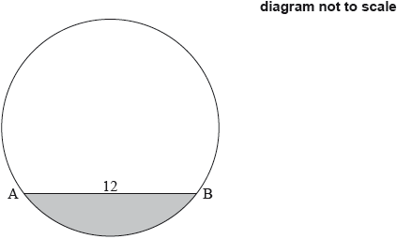

1. Find the area of the shaded segment.
2. Find the perimeter of the shaded segment

Q2 [8]

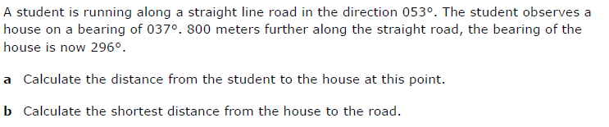

Q3 [6]

Solve the equation for $-π≤x≤π$

$$-6\cos^{2}x+7sinx+8=0$$

Q4 [6]



1. The formulae $f°g\left(x\right) and g°f(x)$ in simpliest form
2. Use your GDC to find the values of x for which 

Q5 [14]

