Test trigonometry

preDP2

name:………………………………………………………………..

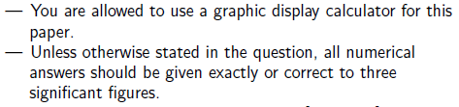

|  |  |  |  |  |  |  |  |  |  |  |
| --- | --- | --- | --- | --- | --- | --- | --- | --- | --- | --- |
| question | 1 | 2 | 3 | 4 | 5 | 6 | 7 | 8 | 9 | sum |
| mark |  |  |  |  |  |  |  |  |  |  |
| max | 16 | 7 | 6 | 9 | 8 | 6 | 6 | 6 | 6 | 70 |





|  |
| --- |
|  |



|  |
| --- |
|  |

 

|  |
| --- |
|  |

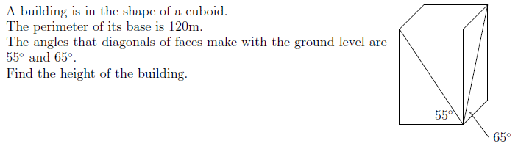

|  |
| --- |
|  |

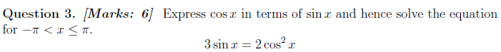

|  |
| --- |
|  |

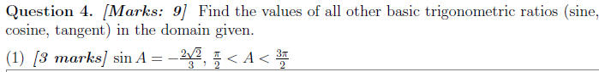

|  |
| --- |
|  |



|  |
| --- |
|  |



|  |
| --- |
|  |

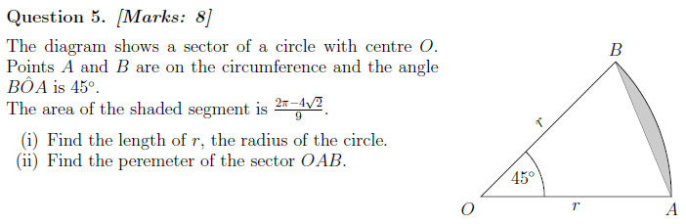

|  |
| --- |
|  |



|  |
| --- |
|  |



|  |
| --- |
|  |



|  |
| --- |
|  |

**Q9*[6marks]*** 