t-Test [43 marks]
1a. [1 mark]
Ms Calhoun measures the heights of students in her mathematics class. She is interested to see if the mean height of male students, $μ_{1}$, is the same as the mean height of female students, $μ_{2}$. The information is recorded in the table.
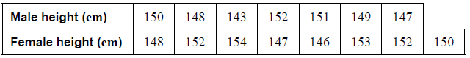
At the 10 % level of significance, a $t$-test was used to compare the means of the two groups. The data is assumed to be normally distributed and the standard deviations are equal between the two groups.
State the null hypothesis.
1b. [1 mark]
State the alternative hypothesis.
1c. [2 marks]
Calculate the $p$-value for this test.
1d. [2 marks]
State, giving a reason, whether Ms Calhoun should accept the null hypothesis.
2a. [2 marks]
The weights of apples on a tree can be modelled by a normal distribution with a mean of $85$ grams and a standard deviation of $7.5$ grams.
Find the probability that an apple from the tree has a weight greater than $90$ grams.
2b. [2 marks]
A sample of apples are taken from $2$ trees, $A$ and $B$, in different parts of the orchard.
The data is shown in the table below.
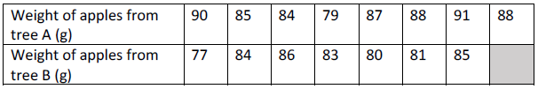
The owner of the orchard wants to know whether the mean weight of the apples from tree $A\left(μ_{A}\right)$ is greater than the mean weight of the apples from tree $B\left(μ_{B}\right)$ so sets up the following test:
$H_{0}: μ_{A}=μ_{B}$ and $H_{1}: μ_{A}>μ_{B}$
Find the $p$-value for the owner’s test.
2c. [2 marks]
The test is performed at the $5\%$ significance level.
State the conclusion of the test, giving a reason for your answer.
3a. [1 mark]
Anita is concerned that the construction of a new factory will have an adverse affect on the fish in a nearby lake. Before construction begins she catches fish at random, records their weight and returns them to the lake. After the construction is finished she collects a second, random sample of weights of fish from the lake. Her data is shown in the table.
Anita decides to use a t-test, at the 5% significance level, to determine if the mean weight of the fish changed after construction of the factory.
State an assumption that Anita is making, in order to use a t-test.
3b. [1 mark]
State the hypotheses for this t-test.
3c. [3 marks]
Find the p-value for this t-test.
3d. [2 marks]
State the conclusion of this test, in context, giving a reason.
4a. [1 mark]
A pharmaceutical company has developed a new drug to decrease cholesterol. The final stage of testing the new drug is to compare it to their current drug. They have 150 volunteers, all recently diagnosed with high cholesterol, from which they want to select a sample of size 18. They require as close as possible 20% of the sample to be below the age of 30, 30% to be between the ages of 30 and 50 and 50% to be over the age of 50.
State the name for this type of sampling technique.
4b. [3 marks]
Calculate the number of volunteers in the sample under the age of 30.
4c. [1 mark]
Half of the 18 volunteers are given the current drug and half are given the new drug. After six months each volunteer has their cholesterol level measured and the decrease during the six months is shown in the table.
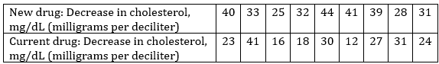
Calculate the mean decrease in cholesterol for
The new drug.
4d. [1 mark]
The current drug.
4e. [1 mark]
The company uses a t-test, at the 1% significance level, to determine if the new drug is more effective at decreasing cholesterol.
State an assumption that the company is making, in order to use a t-test.
4f. [1 mark]
State the hypotheses for this t-test.
4g. [3 marks]
Find the p-value for this t-test.
4h. [2 marks]
State the conclusion of this test, in context, giving a reason.
5a. [1 mark]
Manny and Annabelle, mathematics teachers at Burnham High School, give their students the same examination. A random sample of the examination scores were collected from each of their classes.
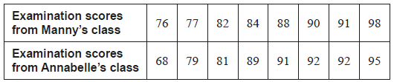
Annabelle uses these scores to conduct a two-tailed $t$-test to compare the means of the two classes, at the $5\%$ level of significance. It is assumed the examination scores for both classes have the same variance and are normally distributed.
The null hypothesis is $μ_{1}=μ_{2}$, where $μ_{1}$ is the mean examination score from Manny’s class and $μ_{2}$ is the mean examination score from Annabelle’s class.
Write down the alternative hypothesis.
5b. [2 marks]
Find the $p$-value for this test. Give your answer correct to five decimal places.
5c. [2 marks]
Annabelle concludes there is insufficient evidence to reject the null hypothesis.
State whether Annabelle’s conclusion is correct. Give a reason for your answer.
6a. [1 mark]
A study was conducted to investigate whether the mean reaction time of drivers who are talking on mobile phones is the same as the mean reaction time of drivers who are talking to passengers in the vehicle. Two independent groups were randomly selected for the study.
To gather data, each driver was put in a car simulator and asked to either talk on a mobile phone or talk to a passenger. Each driver was instructed to apply the brakes as soon as they saw a red light appear in front of the car. The reaction times of the drivers, in seconds, were recorded, as shown in the following table.
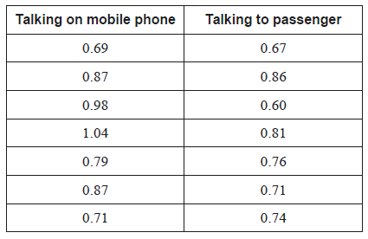
At the $10\%$ level of significance, a $t$-test was used to compare the mean reaction times of the two groups. Each data set is assumed to be normally distributed, and the population variances are assumed to be the same.
Let $μ_{1}$ and $μ_{2}$ be the population means for the two groups. The null hypothesis for this test is $H_{0} : μ_{1}−μ_{2}=0$.
State the alternative hypothesis.
6b. [2 marks]
Calculate the $p$-value for this test.
6c. [2 marks]
State the conclusion of the test. Justify your answer.
6d. [1 mark]
State what your conclusion means in context.

Printed for 2 SPOLECZNE LICEUM
© International Baccalaureate Organization 2023
International Baccalaureate® - Baccalauréat International® - Bachillerato Internacional®

